241501253-YESWANTH T
Zia and built-in analytics
Aim
Evaluate available Zia assistance and Creator analytics for accuracy, privacy and account availability.
Procedure
- Check with an administrator which Zia features your account has; do not assume availability.
- In a development copy, ask Zia for a small validation script using a sanitized prompt (field names only, no real owner data).
- Compare the output with your field dictionary and Experiment 6; correct and keep a correction log; compile before enabling.
- Build native charts: service requests by type, monthly requests, status distribution. Reconcile with hand-counted fixtures.
- If prediction is unavailable, label any AI prediction exercise 'design-only'. Do not report accuracy without a held-out evaluation.

Application images and explanation
Application dashboard: Quick Links, Reorder Level by Quantity Available (scatter) and Spare Part Inventory by Quantity Used (bar)
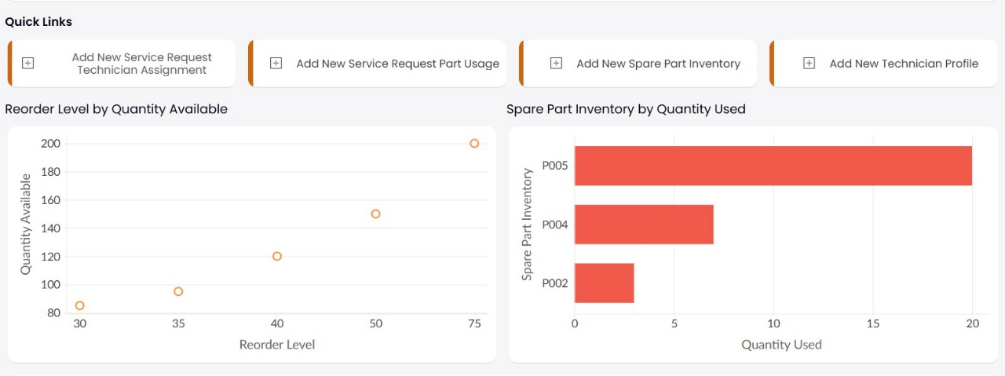
Screenshot from the application.

Process diagram
SANITIZED PROMPT
Field names, no personal data
ZIA DRAFT IF AVAILABLE
Generated in development app
HUMAN REVIEW AND TESTING
Validate syntax and business rules

Generated explanatory diagram. It is not a screenshot of an executed workflow.

Result
Expected result and verification criteria. Available assistance is judged against concrete tests; native metrics reconcile; unavailable features are stated.

